**B2B Travel Company**

Week – 5

For each services we have to make separate-separate pages to display the each services details in a proper way.

Currently the only separate service pages were created with their booking information and the background images and the given photos are given below:

**Flights:**

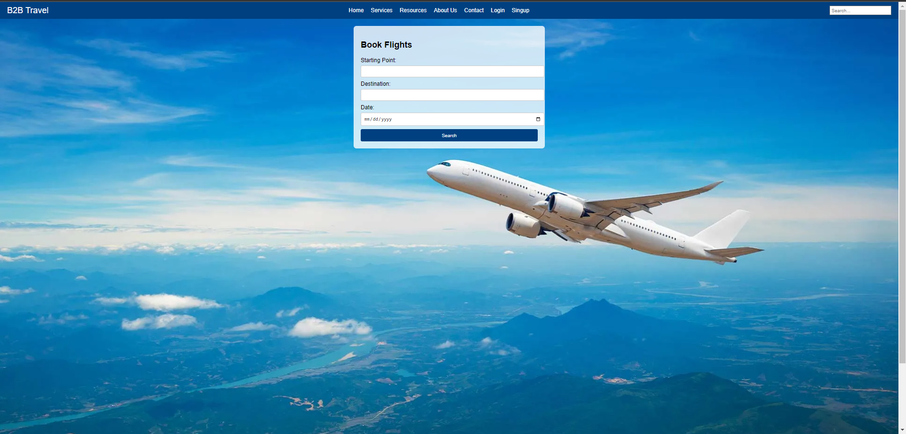

**Trains:**

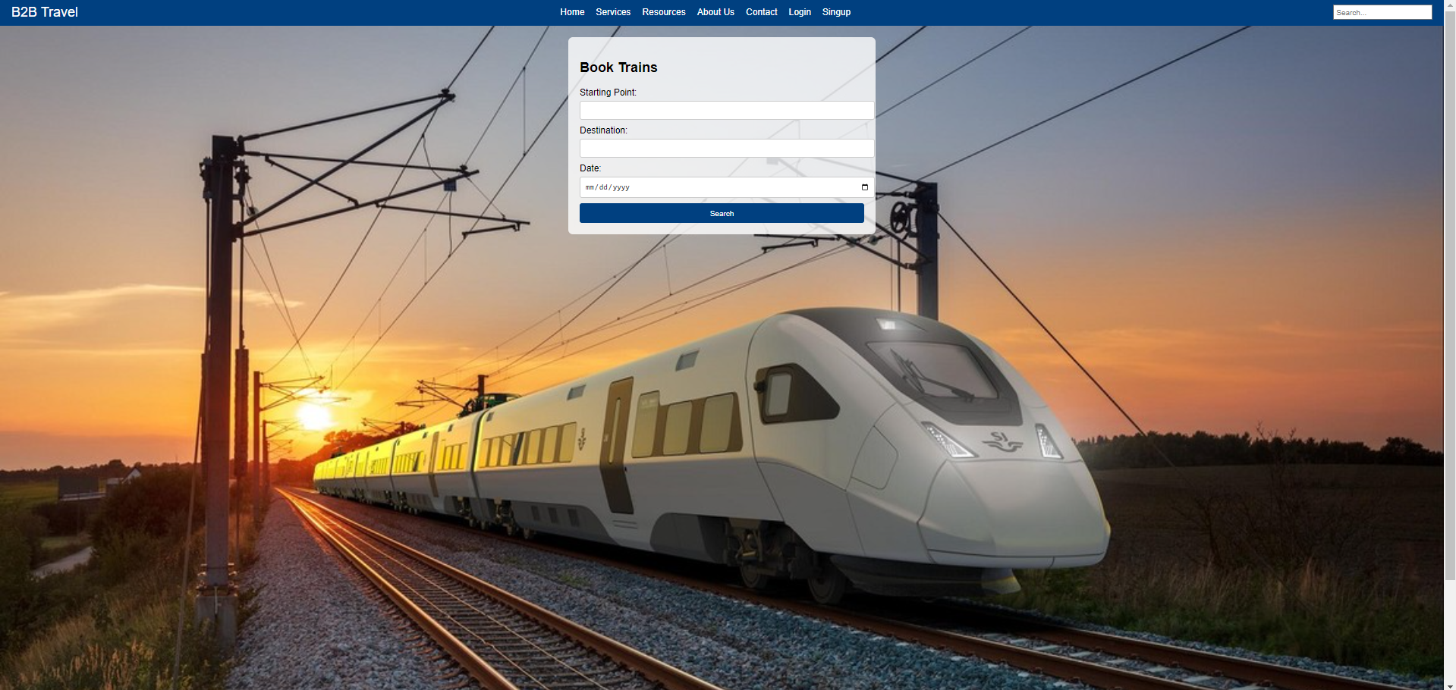

**Buses:**

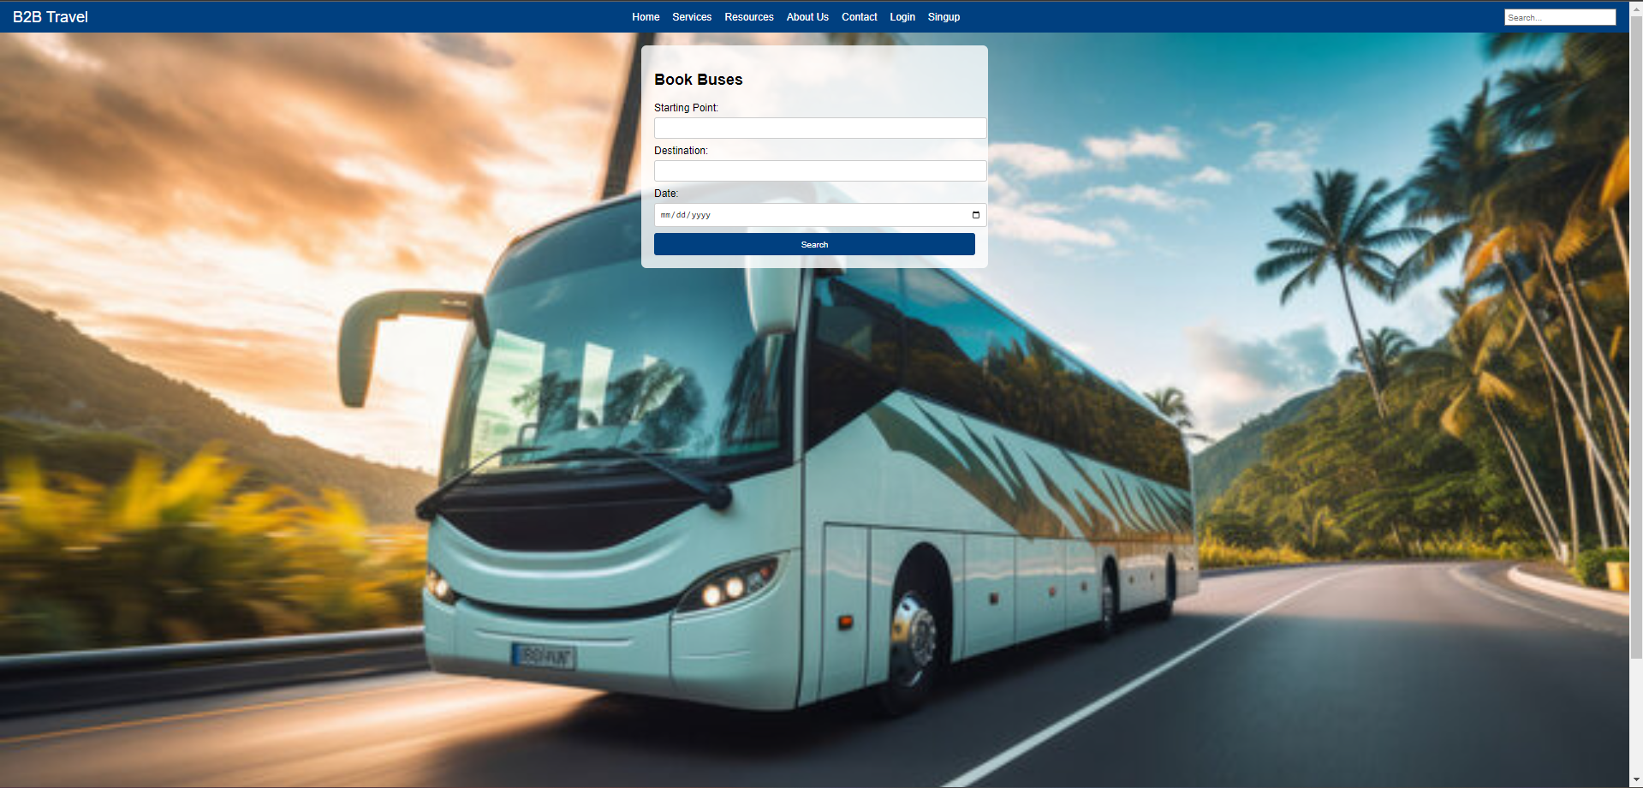

**Cabs:**

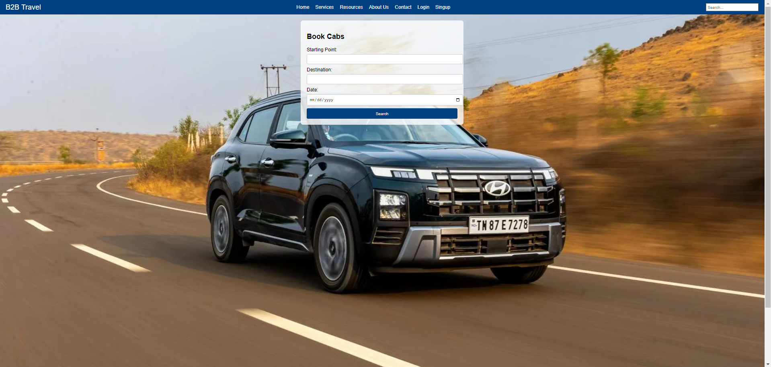

**Hotels:**

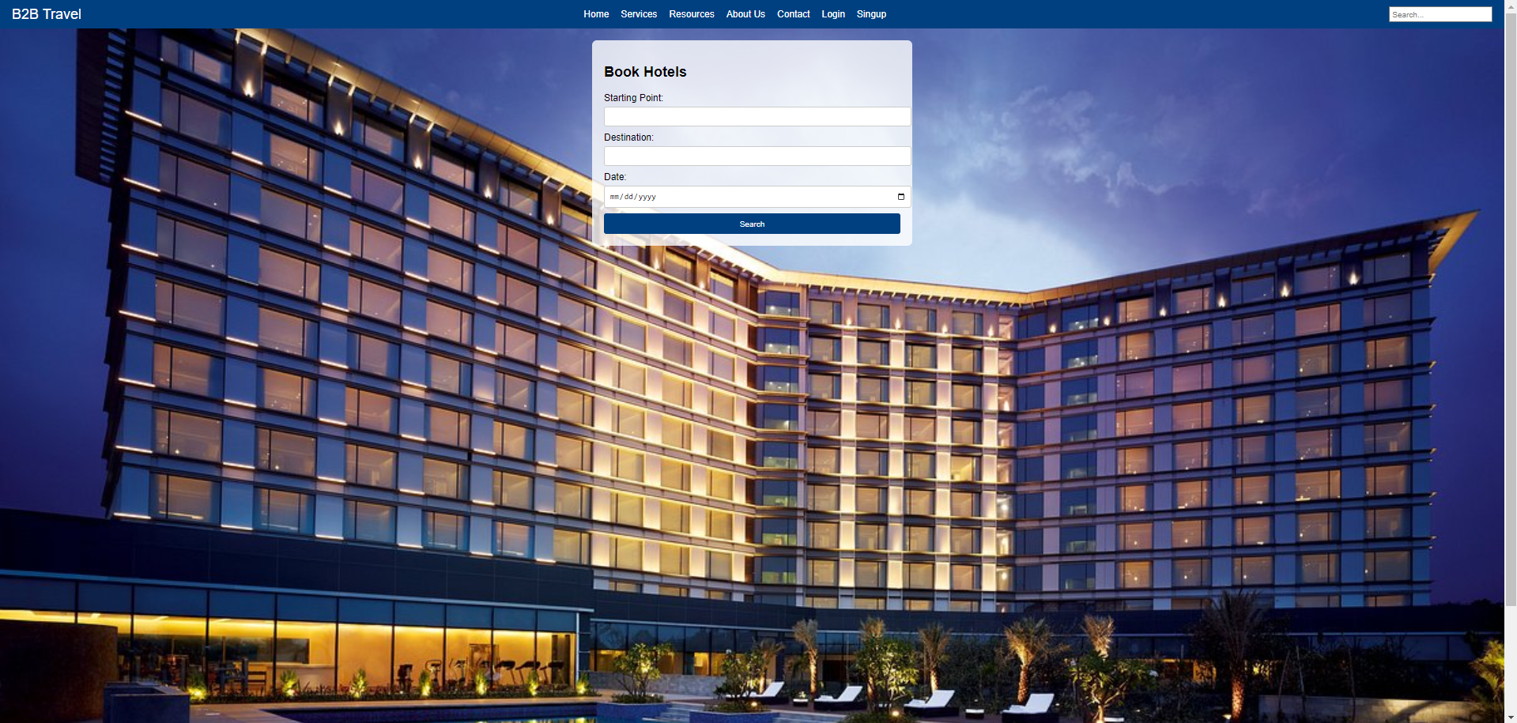

In the next week, after the api integration for all of the services then we will get the complete information about the details of the journey and also the next time the login and signup pages data must be stored in the firebase.